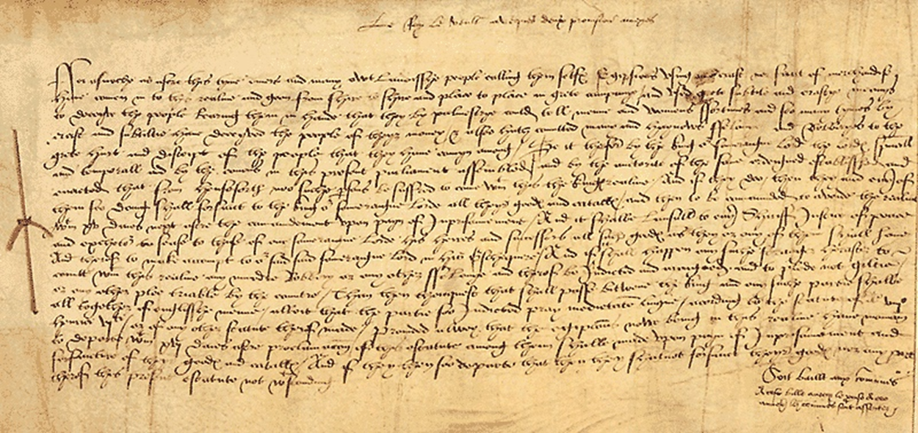
The Egyptians Act, 1530
(Courtesy of the National Archives)

“…a diverse and foreign people, calling themselves Egyptians, using no craft nor evidence of selling goods, who have come into this realm, and gone from shire to shire, and place to place, in great company; and used great subtlety and crafty means to deceive the people and persuading them that they, by palmistry, could tell men's and women's fortunes; and so, many times, by craft and subtlety, have deceived the people for their money; and also have committed many heinous felonies and robberies, to the great hurt and deceit of the people that they move among... the Egyptians who are now in this realm, have to depart within sixteen days.... and from now no Egyptians may enter the King's realm and if they do, then they with all their possessions, shall forfeit to the King our Sovereign Lord all their goods and titles and then must leave the realm within fifteen days under pain of imprisonment.”

